Initial Design of ERD
- The problem describes three entities – Customer, Work Order and Task.
- Customer requests the work order that contains a set of tasks.
- Minimum Cardinality for the Customer-Work order relationship is considered as A single customer can place many number of orders and may have not yet placed an order.(Optional,Many relationship on the WorkOrder side.)
- M-N relationship between WorkOrder and Task can be decomposed into two 1-M relationships between Weak Entity(WorkStatus) which records the status, hours,completion date for a task in a work order.
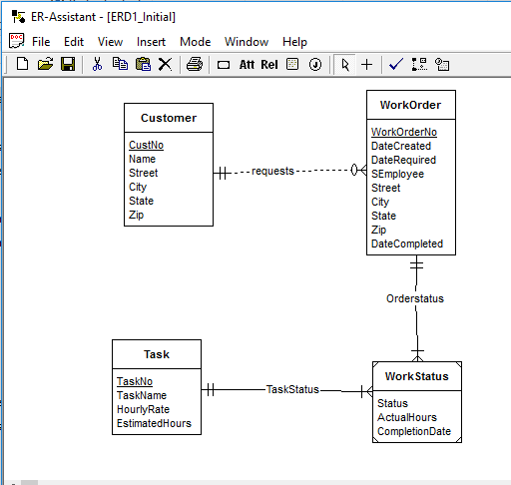

ERD – Revised
- Considering the First Requirement Material Entity was added with attributes as mentioned.
- WorkOrder and Materials Have M-N relationship, it is decomposed into two parts (1-M) relationship.
- EstimatedHours is deleted from Task Entity and was added in the Weak Entity WorkStatus.
